Westport in Brief!
EverythingWestport.com
Sunday, August 15, 2010

Quick Article Index . . .

Golda’s Balcony superb at the library.

Sparkling weather, sparkling wine, sparkling WRWA Gala!

Cruisin’ Route 6.

Golda’s Balcony superb at the library.
EverythingWestport.com
Wednesday, August 11, 2010
Photos/EverythingWestport.com

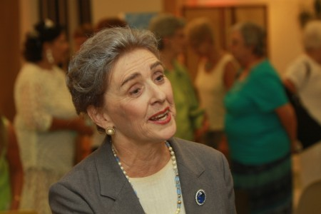
Local actress Linda Monchik brought the lights of Broadway to the Westport Free Public Library. And what a performance it was. It’s easy to see why this Broadway show had a long run.

Reenacting the trajectory of the life of Golda Meir from Russian immigrant to American schoolteacher to Prime Minister of Israel, Monchick delivered a compelling and a high octane-fueled performance that kept the over 100 in attendance glued to their seats. Did you know the world was only a whisker’s breadth away from nuclear conflagration in the Middle East?

Golda Meir was the 4th Prime Minister of Israel and only the third woman elected to such a position anywhere in the world. Much of the show takes place as Golda presides over the Yom Kippur War in 1973. She gave her thoughts about war-time decisions and reminisces about her life, the founding of Israel, and the world leaders and everyday people she has known as a daughter, a wife, a mother, a diplomat, and a politician.

The Friends of the Westport Library presented “Golda’s Balcony,” a one-woman play by William Gibson, to the community as a gift to launch the Westport Library’s Summer Program. Admission was free.

Local actress Linda Monchik, who was the understudy for the Boston premier, delivered a powerful performance. She deftly handled moving through different ages and assumed the identities of multiple people. She brought a production complete with a light-show and sound effects to bring us closer to the full impact of the original Broadway show of over 900 performances. The play ran 90 minutes with no intermission.

In the past 15 years, Linda Monchik has performed regionally, from Boston to Providence and the South Coast, in over 60 shows, with leading roles in most productions. She graduated from Smith College with a minor in theatre and from Emerson College with a masters in theatre. Additionally she trained at the renowned Shakespeare and Company in Lenox, Mass., Brown University and with prominent local artists from Trinity, Gamm and Second Story Theatres.

After only a few minutes Monchik had morphed into Meir, and we all had a side chair to her life story as it happened.

“Monchik charms, beguiles and entrances her audience in all her roles bringing, not only the words of the playwright to life, but the soul of the characters, as well. The imagined becomes real, as she inhabits the characters essence and their needs palpitate. Audiences identify with her characters and journey with her through their travails and triumphs. She heeds the actors’ adage: “Find the character in yourself and yourself in the character.”” – FirePlug

Mixing theatrics with sharp wit and more than a smattering of humor, this historical reenactment had something for everyone. “I’m first an American, second a Secretary of State, and third a Jew,” pleaded Henry Kissinger when pressured by Meir to deliver much-needed armaments.” Well maybe you should read from right to left,” she retorted.

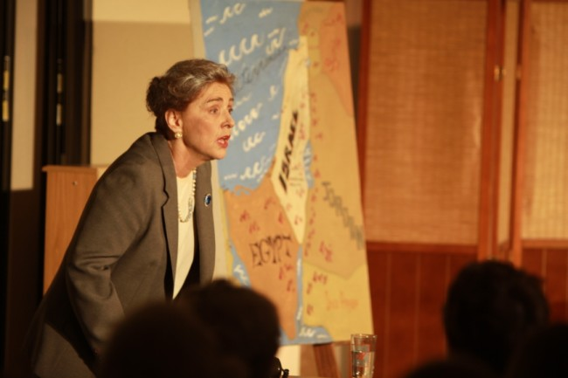
“After 2000 years of exile we have founded our state anew,” Golda Meir had said. “And as Prime Minister I’m presiding over its destruction.” (Spoken by Meir after speaking with Kissinger and Nixon with little results over securing armaments as Israel was at the brink of destruction in the 1973 Yom Kippur War.)

The Israelis had been working on a nuclear bomb for 10 years in a secret facility five levels underground at the Dimona nuclear reactor.

“Two bombs are armed and loaded onto planes,” Meir told Kissinger in 1973. The first bomb has two words written on it: NEVER AGAIN. “They will be dispatched to Cairo and Damascus,” she told Kissinger in a 3:00 a.m. phone call. “Do we get our F4 Phantoms and armaments?”

Kissinger blinked and dispatched 14 C5 cargo planes loaded with arms gathered from the arsenals around Europe to Tel Aviv. “Idealism becomes power,” Meir said as she hung up the phone. The hair stood up on your arms as the C5s flew over the Westport Library.

Winston Churchill saved England from destruction; Golda Meir saved the world.

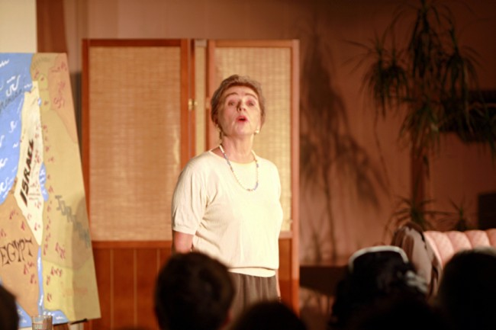

Sparkling weather, sparkling wine, sparkling WRWA Gala!
EveryThingWestport.com
Saturday, August 14, 2010

View photo album of hi-resolution pictures 33 photos | Broadband/DSL speed | Dial-up speed |

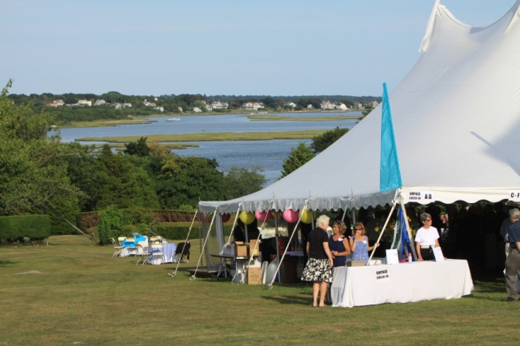
Hundreds turned out on a day filled with brilliant sunshine and social grandeur to support the Westport River Watershed Alliance.

The caterers were superb and vintners of distinction tempted palates with pates and outrageous canopies. Fabulous auction items filled the large show tent waiting for high bidders to take them home. And what stunning waterviews! They were to die for as there are only a handful of Westport properties with a waterfront panorama that includes the West Branch of the Westport River, the Harbor, Buzzards Bay and Cuttyhunk Island.

But this was not your run-of-the-mill, Brahmin affair. Rather it was for a great cause as this annual event raises almost one-fifth of the annual budget needed to carry out WRWA’s projects and to help protect our watershed. And residents and guests from all walks of life came out to show their support.

The Westport River Watershed Alliance’s annual Summer Gala, River Revelry, was Saturday, August 14 at the Fitton Farm, 564 River Road. WRWA’s renowned Silent Auction was the central attraction of the evening. Over 100 exciting donations were available for viewing and bidding, and in addition to the traditional auction, there was also a Fish Bowl Raffle for specially selected items - a fun way for raising funds.

Wilhelmina’s Catering of Little Compton served a delicious selection of hors d’oeuvres while Cardoza’s Wine & Spirits poured a range of spirits as well as selections from Westport Rivers Vineyard, Sakonnet Vineyards, and Just Beer. Spindrift Soda (a fresh take on soda) made a generous donation of fresh sparkling summer flavors. And of course everyone enjoyed the special offerings from Chris Schlesinger’s East Coast Grill, Coastal Roasters, Formaggio Kitchen, Green Gal Catering, Shy Brothers Farm, The Back Eddy, The Bayside Restaurant, and Wicked Kickin’ Savory Cheesecakes. Music, a special collection of “river-themed” music, was provided by City Lights through a generous gift from The Cedars Assisted Living. As in the past, the Gala was a waste-free event with all compostable service items eventually replenishing soils at Sylvan Nursery.

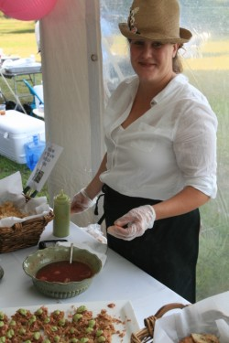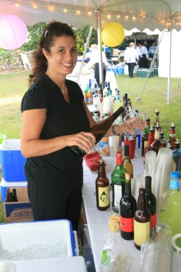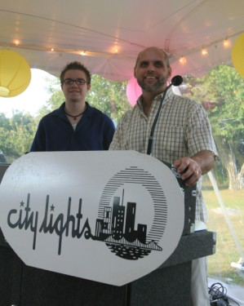
The WRWA wishes to thank their 2010 Gala Corporate Benefactor, Lees Market; and Corporate Sponsors, ABC Rent-A-Tent, Citizens-Union Savings Bank, Elegant Restrooms of Rent-A-Jon, Fiduciary Trust Company International, Katzenbach & Company Real Estate, Lees Oil Service, Inc., Mechanics Cooperative Bank, Sovereign Bank, Waring-Sullivan Homes of Memorial Tribute, Westport Federal Credit Union and Westport Rivers Vineyard & Winery. Their ongoing support ensured a Gala to remember.

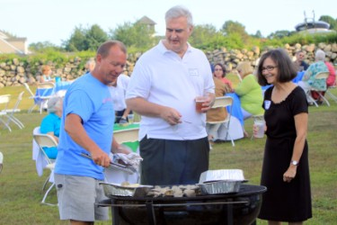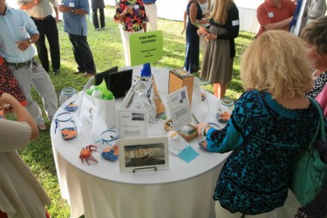

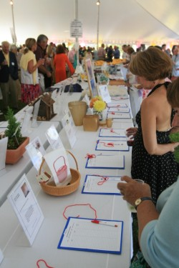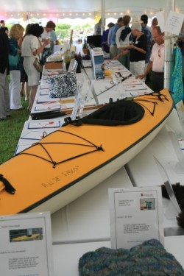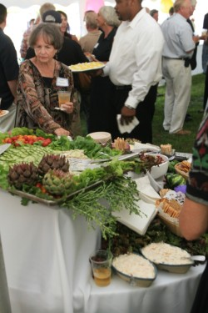

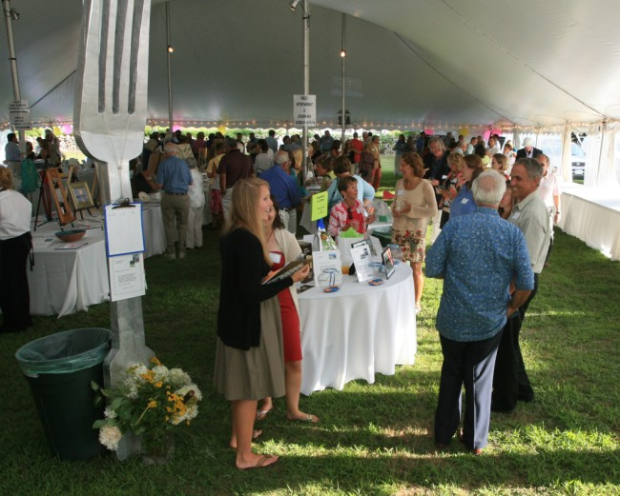

For more information and questions on picking up silent auction items, please call (508) 636-3016, or drop by their office at 1151 Main Road in Westport, MA. WRWA’s website is: www.westportwatershed.org.

Cruisin’ Route 6.
EveryThingWestport.com
Sunday, August 15, 2010

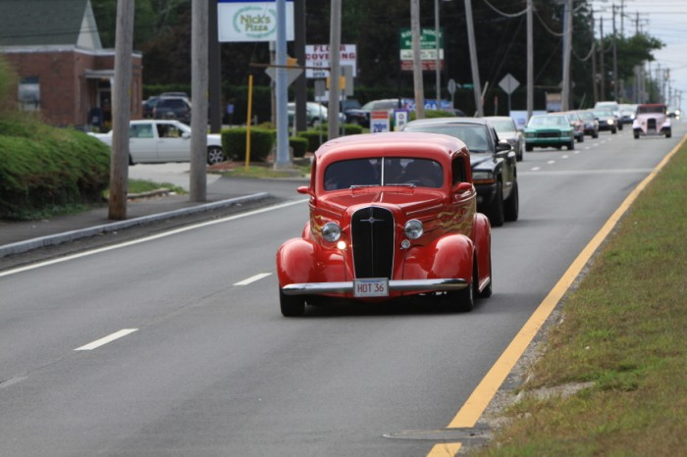
Hot rods, muscle cars, bikes, trucks and pick-ups, vintage cars, and low riders cruised along Route 6 Sunday in California style! A group of merchants including the Premium 70/70 Cigar Shoppe, Distinctive Auto Refinishing and Sales, Westport Bicycle Shop, Lickety Splits Ice Cream and other restaurants and Route 6 businesses joined together to celebrate the ‘60s and Route 6’s recent repaving by sponsoring a “Smooth Cruise” along Westport’s storied highway. The elder teenagers brought their toys and best girls to cruise the Main.

Hey, if you can’t tell how many cubic inches by the rumble of the exhaust, then man, you just don’t want to know. But what you should know is that proceeds from this Route 6 Revival Food Special benefited the Special Olympics of Southeastern Massachusetts.

More than 100 cars, bikes and trucks including a local envoy from the Angels Car Club cruised up and down along newly refurbished Route 6, Westport’s first highway. Free entertainment along with T-shirts and memorabilia, food and fun completed the celebration.

View photo album of hi-resolution pictures 20 photos | Broadband/DSL speed | Dial-up speed |

And, yah, that was State Representative Mike Rodrigues and Westport Selectman Paul Schmid tooling down State Road in the orange Model A roadster. Miss a shift, Mike?

Rodrigues is running for State Senate and Schmid is running for Rodrigues’ seat. Move over Mike and let Paul drive.

Thanks to restaurant sponsors: Gregorio’s Italian Pizzeria, Oriental Pearl Restaurant, Olympia Pizza, Captain Clams, Westport Kartway, Lickety Splits, and Portas DaCidade.

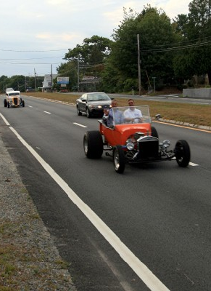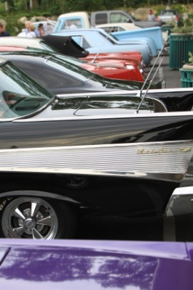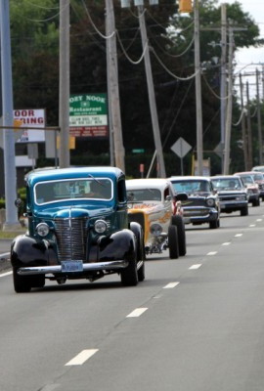
Left: Mike Rodrigues (driving) and Paul Schmid get some air time in this small block-Chevy powered Model A roadster. Center: Remember the days when you could tell the make, model and year simply by the taillights? Right: Route 6 gets a convoy.

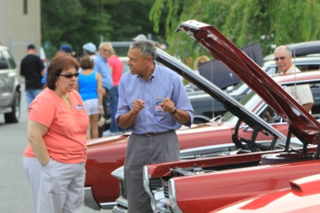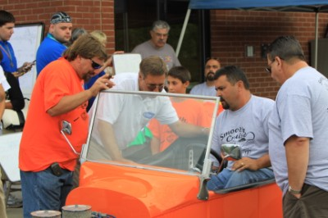
Left: Paul Schmid makin’ a pitch for the 390 CI Ford Fairlane. “It was my first car,” said the State Representative hopeful. Right: Rui Cordeiro (seated) explains the intricacies of his beautiful roadster to State Representatives Mike Rodrigues (center) while cigar-man Don Rodrigues looks on.

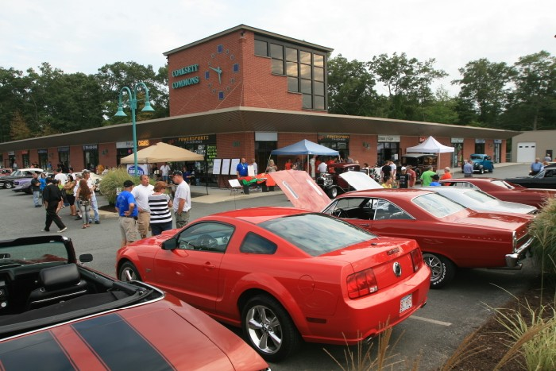

- - - - - End - - - - -

© 2010 Community Events of Westport All rights reserved.
EverythingWestport.com

